Data Sheet

KEN Washer Disinfector IQ3
Standard Range Features  - OLED Display with soft touch program keys on control panel  - Open Programs Structure  - Very low water consumption  - Low Noise Levels  - Low Energy Costs  - Maintenance free sliding doors  - Service access from the front  - EN ISO 15883-1-2-5-6 compliant  - Glass surfaces easy to clean | 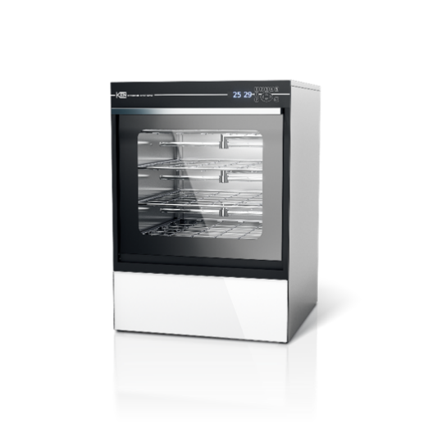  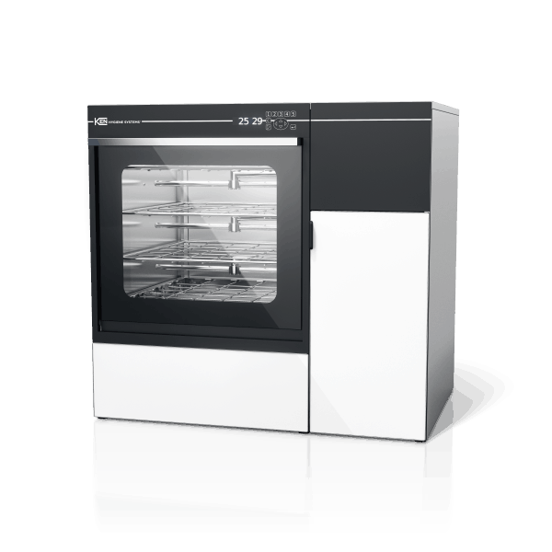

IQ3
Outer dimensions  Outer dimensions with side cabinet | H: 840 x W: 600 x D: 630 mm  H: 840 x W: 900 x D: 630 mm
Wash chamber dimensions | H: 490 x W: 540 x D: 556 mm
Operative volume, wash chamber | 150 Litres
Total chamber volume | 170 Litres
Capacity of DIN baskets (480x250x50mm) | 4x2 DIN Baskets
Water consumption per phase (4 level rack) | 8-14 litres
Programs | 10 Standard + 30 optional
Process times | Standard 40-60 min.
Water connection | 1 x ¾” (2 x ¾” are optional)
Cold water Pressure | 2-8 Bar, ≥15L/min, 5-30˚, 0-30˚dH
Hot water | 2-8 Bar, ≥15L/min, 30-70˚, 0-3˚dH
Demineralised/RO water | 2-8 Bar, 15L/min 5-70˚ cond. 0-200μS
Condenser | Standard

* The above is the standard specification. Any modification/deviation for the above will be clearly identified on the quotation front sheet.

Additional Options and Accessories: XML server Connection
Printer
2 x Additional Water Connections
Drying Module

